Determining Suitable Conditions Required for Finger Millets Seeds Germination Using Decision Tree Algorithm

Mohammed Azam Sayeed¹, Harshitha R², Noor Ayesha³
¹Department of Computer sciences, SET Jain University Bangalore -562112
²Department of Electronics and Communication, Siddaganga Institute of Technology

Abstract— This paper presents a methodology to determine the optimal conditions that would be required for the germination of crops using data generated from multiple sensors on Arduino Uno, collected and analyzed in python using the state of the art Decision Tree Model. These Insights can be utilized by farmers and agricultural scientists to enhance crop productivity, yield and revenue generation.

Keywords— Decision Tree, CART, Feature Importance, Ruleset, Ragi Seed Germination, Optimal Conditions, Environmental Factors, Light, Temperature, Humidity, Soil Moisture Content, Arduino Uno, LM35, LDR, DHT11, Soil Moisture Sensor, Entropy, Information Gain, Root Node
- determining optimal conditions for germination of crop
The environment is everything that is around us. It can consist of living or non-living things. It includes physical, chemical and other natural forces. Living things live in their environment. They constantly interact with it and adapt themselves to conditions in their environment. Plant growth and Plant’s geographic distribution are greatly affected by the environment. If any environmental factor is less than ideal, it limits a plant's growth and/or distribution. Either directly or indirectly, most plant problems are caused by environmental stress. In some cases, poor environmental conditions (e.g., low soil moisture) damage a plant directly. In other cases, environmental stress weakens a plant and makes it more susceptible to disease or insect attack. Environmental Factors include physical conditions and non-living resources that affect living organisms in terms of growth, maintenance, and reproduction. Such factors affect plant growth include light, temperature, soil moisture, and humidity. It is important to understand how these factors affect plant growth and development. With a basic understanding of these factors, you may be able to manipulate plants to meet your needs, whether for increased leaf, flower, or fruit production. By recognizing the roles of these factors, you also will be better able to diagnose plant problems, ideal growth conditions and plant stress caused by environmental factors.

The Environmental factors that affect plant growth conditions that will be studied in this paper are as below
- Temperature and Light:
The biochemical functions in plants that are required for growth and survival are `temperature dependant’ – that is there is an optimal temperature range within which a particular plant species will be carrying out photosynthesis at its maximum rate (given that sufficient CO2, water and light are also present). Outside this range, photosynthesis and other plant processes begin to slow down, to the point where they stop and growth ceases. Since different plant species have different ideal temperature ranges, this needs to be matched to the crop being produced for cool and warm grown crops.
Outside these ranges, plant growth slows due to either condition being too cold and slowing chemical reactions inside plant cells or becoming too hot, which denatures enzymes and causes cell death. For this reason, it is possible to `accelerate' plant growth by preventing any environmental factors like temperature from becoming the limiting factor in plant growth by varying the speed at which the biochemical reactions such as photosynthesis can be carried out within the plant's tissues.

Temperature and light are linked through the processes of photosynthesis and respiration. Photosynthesis builds sugars and starch, which are then broken down by respiration to provide energy for the development of new tissues (growth) and the maintenance of existing ones. High temperature speeds up respiration. If the plant is not producing sufficient sugars (as under low light), then high temperatures may break down what little sugars are made, leaving little to none for growth. Maintenance takes precedence over growth; therefore, under insufficient light, plants do not grow. If the light is so low that sugars produced are insufficient for maintenance, the plant eventually dies.
When sugar levels are low, the plant takes nutrients and sugars from older leaves to maintain new leaves. To help plants in an indoor environment, two options are available: (1) raise light levels to increase photosynthesis and sugar production or (2) reduce night temperature to lower respiration rates and allow more sugars for growth.
Also Too much or too little light can quickly stress a plant, which makes them more prone to disease, pests, and premature death. However, finding optimal lighting for your plant can take some trial and error experiments. Crops may either need direct bright sunlight or indirect low light based on plants' physiological requirements.

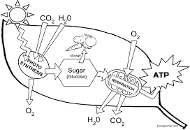
Fig. 1 photosynthesis and Transpiration in the chloroplast of a leaf dependent on Light and Temperature
- Soil Moisture:
Soil moisture and its availability to support plant growth is a primary factor in farm productivity. Too little moisture can result in yield loss and plant death. Too many causes root disease and wasted water. The optimal amount of moisture in the soil leads to healthier crops and higher yields.

Few Important Soil Moisture Terms
- Saturation: When water enters a soil volume more quickly than it is moved downward by gravity, it becomes saturated. Saturation is formally defined as the condition where all soil pores/voids are filled with water. Saturated soil is heavy, contains little air, and can be thought of like mud.
- Field Capacity: With time (the amount of time depends on soil type), substantially all of the water that will drain due to gravity has drained. The soil solution is now in balance, containing all of the water that can be held by surface tension. This condition is referred to as Field Capacity. At Field Capacity, water is easily available to plants, and the soil solution contains ample oxygen. Optimal growing conditions for most plants occur at Field Capacity or slightly drier than Field Capacity.
- Management Allowable Depletion: 'Management Allowable Depletion' (MAD) is the lowest moisture level that can be sustained by plants without adverse stress effects. Any moisture content below this level is in the 'Stress' zones.
- Permanent Wilting Point: As soil is subject to evaporation and withdrawals from plants, water content decreases and tension increases to a point where plants can no longer extract water. Maintaining soil at this level for any length of time can cause permanent damage to plants.

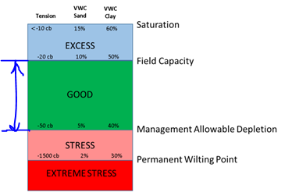
Fig. 2 Soil Moisture Terms for Optimal plant growth

Thus for Optimal plant growth, we need soil moisture content to be in the range of Field Capacity to Management Allowable Depletion level, this range is determined by intensive research and expertise on the agricultural sciences.

- Humidity:
The relative humidity is the amount of moisture contained in the air. The relative humidity is a very important factor, but it is easily overlooked. Rapid transpiration and water loss may result in stressing the plants as it speeds up respiration. If the plant is not producing sufficient sugars (as under low light), then high temperatures may break down what little sugars are made, leaving little to none for growth. Maintenance takes precedence over growth; therefore, under insufficient light, plants do not grow. The optimal rate of transpiration and environmental Factor such as Humidity is plant-specific and is determined by various experiments and research by the agricultural scientist.

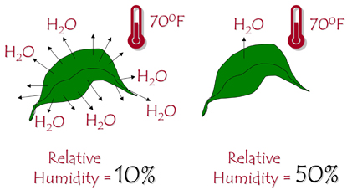
Fig. 3 Transpiration dependent on Relative Humidity

Finger Millet Crop (Ragi):
Nutritionally it is almost as good as or better than wheat or rice. The major proteins of ragi are prolamins and glutenins and they appear to be adequate in all the essential amino acids. Ragi is rich in minerals especially calcium. It is also rich in fiber. It is also rich in phytate and tannin and hence interferes with mineral availability. It contains B-vitamins but is poor in B2. Malting of finger millet is a traditional process followed in India and is used in infant foods and milk thickener formulations conveniently called ragi malt. The grain is also malted and the flour of the malted grain is used as nourishing good for infants and invalids. Malting releases the amylases which dextrinize the grain starch. An added advantage of malting ragi is in the production of an agreeable odor developed during the kilning of the germinate d grain. Malted ragi flour is called 'ragi malt' and is used in the preparation of milk beverages.

We have chosen Finger Millet Crop for this paper because of its high nutritional value and also because of its fast rate of germination, In Optimal Conditions, the seeds can germinate in 8 hours to a maximum period of 5 days. Due to its convenience of growing the crop and fast germination, Finger millet is a good choice for research.

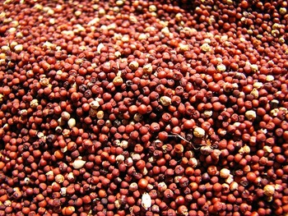
Fig. 4 Finger Millet Seeds (Ragi)

As Explained Earlier for Optimal growth for Crop/Plants, Environmental factors play a major role. Thus it is advisable to grow the crop in the optimal range of Environmental factors such as Light Intensity, Temperature, Soil moisture content, and Humidity. The Optimal range of Environmental Factors for plant health is plant species-dependent and requires intensive research by agricultural scientists and botanists. This Paper will try to estimate the Optimal Environmental factors range required for optimal germination Finger Millet seeds using State of the Art Decision Tree Algorithm on multiple data collected From Sensors described in the next section.

- HARDWARE REQUIREMENT TO GENERATE DATA

  - Circuit Diagram:
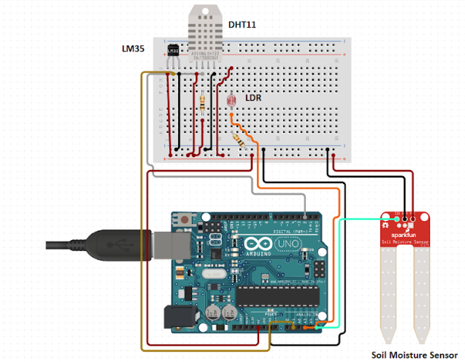
Fig. 5 Breadboard connection of Arduino Uno to multiple sensors
- The Arduino Uno:
The Arduino Uno is a microcontroller board based on the ATmega328, It has 14 digital input/output pins, 6 analog input, a 16 MHZ crystal oscillator, a USB connection, a power jack, an ICSP header, and a reset button. The Uno differs from all preceding boards in that it does not use the FTDI USB to serial driver chip. The Arduino Uno can power via the USB connection or with external power supply. External power can come either from an AC to DC adapter or battery. The board can operate on an external supply of 6 to 20 volts. If supply with less than 7v, however, the 5v pin may supply less than five volts and the board may be unstable. The Ttmega328 has 32 KB of flash memory for storing code. It has also 2KB of SRAM and 1KB of EEPROM. The Arduino software includes a serial monitor which allows simple textual data to be sent to and from the Arduino board, The RX and TX LEDs on the board will flash when data is being transmitted via the USB to serial chip and USB connection to the computer.

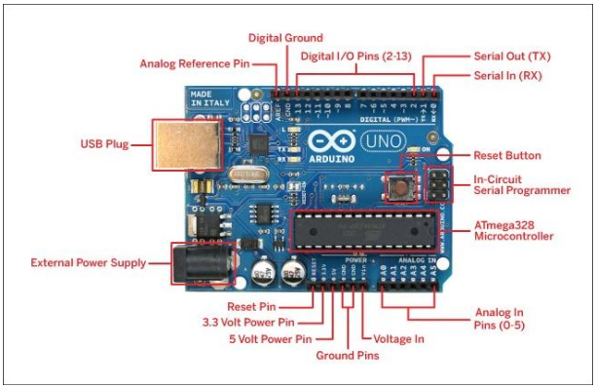
Fig. 6 Arduino Uno
- LM35 Temperature Sensor:
LM35 is a precession Integrated Circuit Temperature sensor, whose output voltage varies, based on the temperature around it. It is a small IC that can be used to measure temperature anywhere between -55°C to 150°C. It is interfaced with Arduino by connecting Arduino's digital I/O pin to the Output pin of LM35. IC is powered by applying a regulated voltage of +5V (VS) to the input pin and connected the ground pin to the ground of the circuit. The temperate is measured in the form of voltage.
If the temperature is 0°C, then the output voltage will also be 0V. There will be a rise of 0.01V (10mV) for every degree Celsius rise in temperature. The voltage can be converted into temperature using the below formulae.
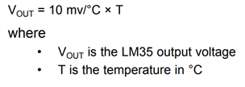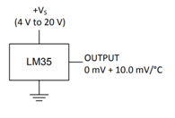
Fig. 7 Mathematical Equation(left) and circuit diagram(right) for LM35

- Soil Moisture Sensor:
The two copper leads act as the sensor probes. They are immersed in the specimen soil whose moisture content is under test. The conductivity of soil depends upon the amount of moisture present in it. It increases with an increase in the water content of the soil that forms a conductive path between two sensor probes leading to a closed path to allow current flowing through. The electrical resistance is measured between the two electrodes of the sensor. A comparator activates a digital output when the adjustable threshold is exceeded. It can be used to measure in the range from 0 to 70% moisture content in the soil.
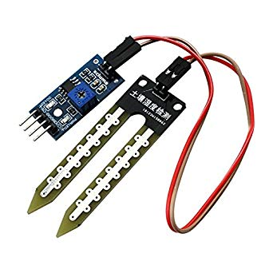
Fig. 8 Soil moisture Sensor for Arduino Uno

- LDR Light Sensor:
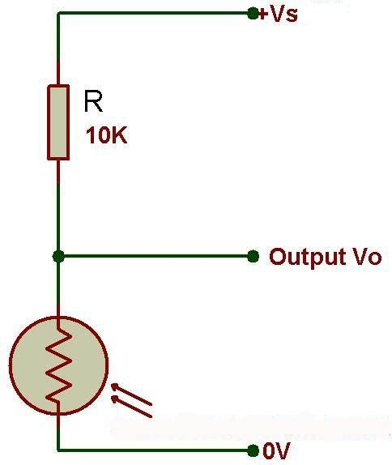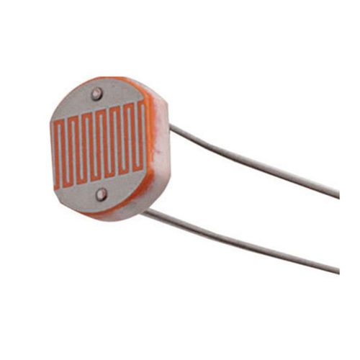
Fig. 9 circuit diagram of LDR sensor Fig 10 LDR Sensor

The light sensor is extremely sensitive in the visible light range. The LDR is a special type of resistor which allows a lower voltage to pass through it (high resistance) whenever its dark and higher voltages to pass (low resistance) whenever there is a high intensity of light. The varying resistance of the LDR is converted to a varying voltage that the analog pin of the Arduino will then be used in its logic. we have set a threshold that will take data as 0 – for Bright light(greater than a threshold) other as 0 representing low-intensity light.

- Humidity Sensor (DHT11): The DHT11 measures relative humidity. The relative humidity is the amount of water vapor in air vs. the saturation point of water vapor in the air. At the saturation point, water vapor starts to condense and accumulate on surfaces forming dew.
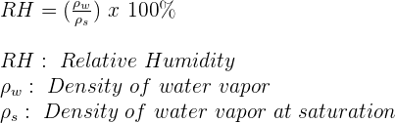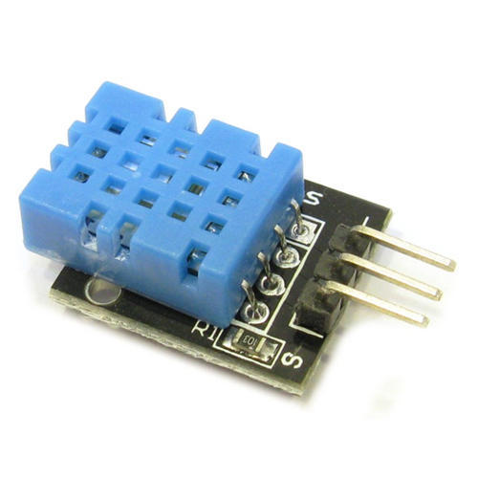
Fig. 11 Mathematical Equation(left) and circuit diagram(right) for DHT11

The relative humidity is expressed as a percentage. At 100% RH, condensation occurs, and at 0% RH, the air is completely dry. The DHT11 uses just one signal wire to transmit data to the Arduino. IC is powered by applying a regulated voltage of +5V (VS) to the input pin and connected the ground pin to the ground of the circuit. A 10K Ohm pull-up resistor is needed between the signal line and the 5V line to make sure the signal level stays high by default. The sensor can measure from a range of approximately 20-90% RH.

- Introduction to Decision Tree algorithm

[2] A decision tree (it may be also called Classification Tree) is a predictive model that can be used to represent the classification model. The use of decision trees is very popular in data mining due to its simplicity and transparency. Decision trees are usually represented graphically as a hierarchical structure that makes them easier to be interpreted than other techniques. This structure mainly contains a starting node (called root) and a group of branches (conditions) that lead to other nodes until we reach a leaf node that contains the final decision of this route. The decision tree is a self-explanatory model because its representation is very simple. Each internal node tests an attribute while each branch corresponds to attribute value (or range of values). Finally, each lead assigns a classification.

Example of Decision Tree constructed using CART Algorithm is as below

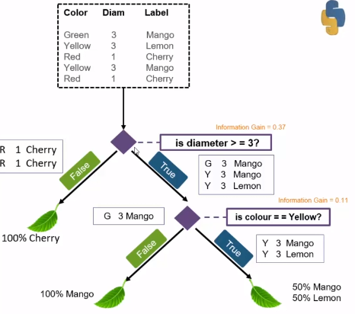
Fig. 12 Constructed Decision Tree

In the above example, The entire dataset is given to the Root node. At each node there is a decision/Question asked about one of the features,based on true or false the dataset is partitioned into subsets which will, in turn, be the input to the consequent nodes. The Objective of the Question is to produce pure subsets having the same Target labels. The process of framing Questions is done recursively until we can have pure labeled subsets.
Few Question framed in above Example would be as
1. Is diameter >=3
2. Is the color yellow
These Questions/decisions will be used to partition the data to pure subsets of Mango, Cherry and Lemon Labels.

Decision Tree Terminologies:
1. Root Node: It represents the entire population or sample, and this further gets divided into two or more homogenous sets.
2. Leaf Node: Node cannot be segregated further in nodes (Gini index =0 at a leaf node)
3. Splitting: Dividing the root node/sub node into different parts based on some condition.
4. Subtree: Intermediate step of splitting a tree
5. Pruning: Removing unwanted branches from the tree
6. Parent/Child node: Root node is the parent node and all other nodes branching from it is called child node

Metrics used by Decision Tree to Split Data:
1. Entropy: Defines randomness in the data. It is a metric which measures the impurity. The first step to solve the decision tree problem.
2. Information Gain: The information gain is the decrease in entropy after a dataset is split based on an attribute. Constructing a decision tree is all about finding an attribute that returns the highest information gain.
3. Gini Index: The measure of impurity (or purity) used in building the decision tree is the Gini index.
4. Reduction invariance: Algorithm used for continuous target variables (regression problem). The split with lower variance is selected as the criteria to split the population.

Below is the illustration of Entropy formula computation for two target labels Yes or No calculated as below

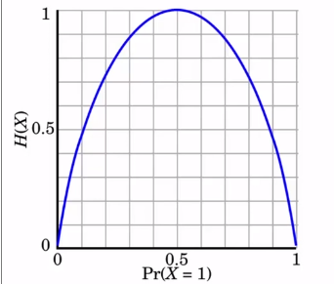
E(S) = -P(Yes)log2 P(Yes)-P(No) log2 P(no)
When P(yes)=P(no)=0.5 , Equal no. of yes and no
E(S) = -0.5log2 0.5 - 0.5 log2 0.5
E(S) =-0.5(log2 0.5 - log2 0.5) =1E(S) = -P(Yes)log2 P(Yes)
When P(yes)=1 , Only yes in sample space
E(S) = 1 log2 1 =0
Similarily for P(No)=1 Only no in sample space
E(S) = 1 log2 1 =0

Also Information Gain = Entropy(S) -[(Weighted Avg)x Entropy(each feature)] ; s- total collection

Fig. 13 Plot of Entropy vs Probability (left) and Calculation of Entropy and Information Gain(right)
The simplistic CART algorithm for decision tree would be as follows:
Step 1: Compute the entropy for the entire dataset (similar to Fig 7 for binary labels)
Step 2: Calculate Information Gain using Entropy for each attribute.
Step 3: Select the root node based on Step 2 with the attribute of maximum Information Gain.
Step 4: Recursively grow tree Nodes based on the attribute of maximum Information Gain calculated by Step 2.
till data is divided into homogeneous label subsets.

So, We are using Decision Tree for this paper for below reasons:
1. Decision made by decision Tree is based on conditions like If else statements in programming constructs, which makes it easier to explain and understand
2. The Graphical Representation of decisions made provides High Interpretability as it is easier understandable to what conditions the tree has classified the dataset
3. Easy to compute and explain why a particular variable is having higher importance, desire for simple model, limited computational power, model transparency, and simplicity is more important than high accuracy of the model.

Since we have Intuition of the Various Environmental Factors that impact the optimal growth of plants such as Temperature, Light, Soil moisture and Humidity. We have chosen Decision Tree as our goal is an exploratory analysis and to understand how these environmental factors contribute to optimal seed germination.

- Implementation of Decision Tree in python
  - Data Collection:
Ragi seeds were planted under various conditions such as seasons and various locations in southern India and observed for 7 days. Ideal conditions should allow germinations of the ragi seeds in a maximum of 2 days. Data is collected from Hardware system as Fig 4 along with the target variable with 0 representing as Not Favourable conditions and 1 for Favourable Condition for Ragi seed Germination respectively. 20 plantation data was collected with the corresponding observed target label with 11 samples being the favorable condition for seed germination (Target as 1) and 9 samples not a favorable condition for seed germination (Target as 0). Output Data collected from the sensors with delay time are collected in the Ardunio interface to Python IDE and saved in excel format as below sample Table for exploratory analysis by a decision tree.
TABLE I
Sample Sensor data generation for Finger Millets Seed germination
Sno | LM35 | Moisture | DHT11 | LDR | Target
1 | 27 | 0.33 | 0.2 | 1 | 1
2 | 26 | 0.3 | 0.22 | 1 | 1
3 | 25 | 0.3 | 0.2 | 1 | 1
4 | 30 | 0.39 | 0.25 | 1 | 1
5 | 16 | 0.55 | 0.18 | 1 | 0
… | … | … | … | … | …

  - Decision Tree Construction using CART Algorithm
- Read data cleansed Excel file:
The data saved in the XLSX file is read and processed using the Pandas package in python.
import pandas as pd
dataset = pd.read_excel("dataset.xlsx")

Fig. 14 Reading xlsx file
- DecisionTree Classifier generation from sklearn:
We are using a sklearn package for DecisionTreeClassifier Model and train_test_split for validation of the model for the classification problem with two target labels 1 and 0.

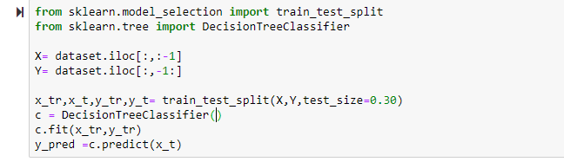
Fig. 15 DecisionTreeClassifier Model using sklearn
- Evaluation of the Model:
This step will help to understand if the Decision Tree Model is a good choice to proceed with the analysis of insights, the metrics such as accuracy score, confusion matrix and ROC curve computed from train_test_split in Fig 10 are used on the validation set. The model has shown a high accuracy of approximately 0.82. Thus Decision Tree is a good choice for our problem statement as depicted below.

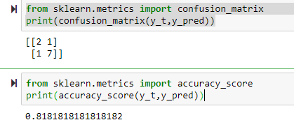
Fig. 16 Confusion Matrix and accuracy score

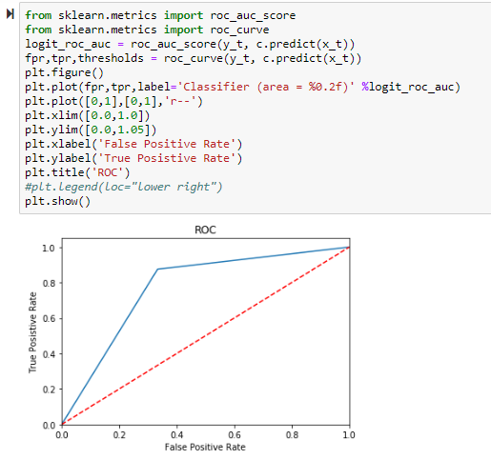
Fig. 17 ROC Curve

- Evaluating Feature Importance and Graph Generation
From Feature Importance, we can see that Temperature data generated from LM35 sensor has the highest impact on the classification to Favourable or Unfavourable Environmental factor for Ragi seed germination followed by LDR(Indirect Low light or direct bright sunlight represented by 0 and 1 respectively), DHT11 Humidity sensor and Soil moisture sensor. It is observed all 4 Environmental factors do contribute to the Optimal condition for ragi seed growth.
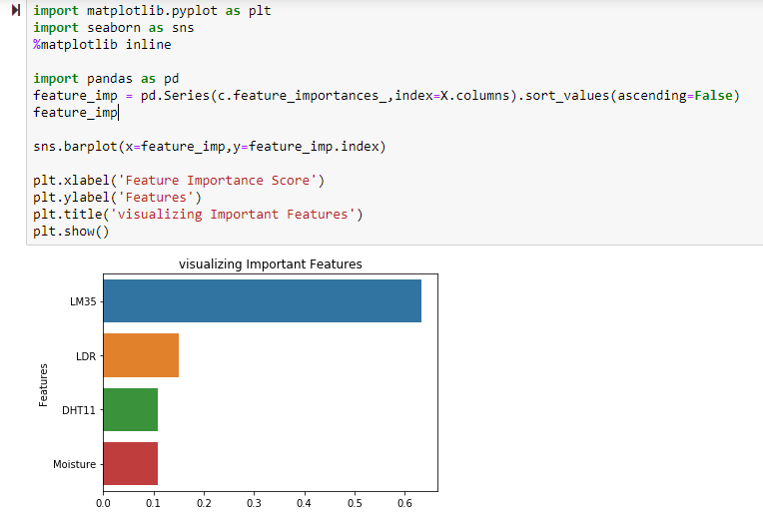
Fig. 18 Feature Importance

The Tree Constructed by the Decision Tree Model can be graphically represented by the pydotplus package as Fig 21.
The code snippet is as below
from IPython.display import Image
from sklearn import tree
import pydotplus
from sklearn import datasets
# Create DOT data
dot_data = tree.export_graphviz(c, out_file=None, feature_names=X.columns, class_names=['Unfavorable','Favorable'])
# Draw graph
graph = pydotplus.graph_from_dot_data(dot_data)
# Show graph
Image(graph.create_png())

Fig. 19 Graph generation using pydotplus package

- Saving the Model and Graph to Disk for later reference:

# Create PNG
graph.write_png("decisionTree.png")

import pickle
from sklearn.externals import joblib
# save the model to disk
filename = 'finalized_model.sav'
pickle.dump(c, open(filename, 'wb'))

# load the model from disk
loaded_model = pickle.load(open(filename, 'rb')

Fig. 20 Save Model using Pickle and Graph to Disk

  - Comprehension and Insights of generated Rule
The step will involve assessment and studying of Favourable conditions for ragi seed germination from the sensor-generated values dataset. This will help in understanding the Required Stimulated environment such as a greenhouse or location choice that can be provided for Ragi crop for maximized harvest and profit for the farmers. It also can bridge the gap between supply and demand of the crop by increasing the output of harvest.

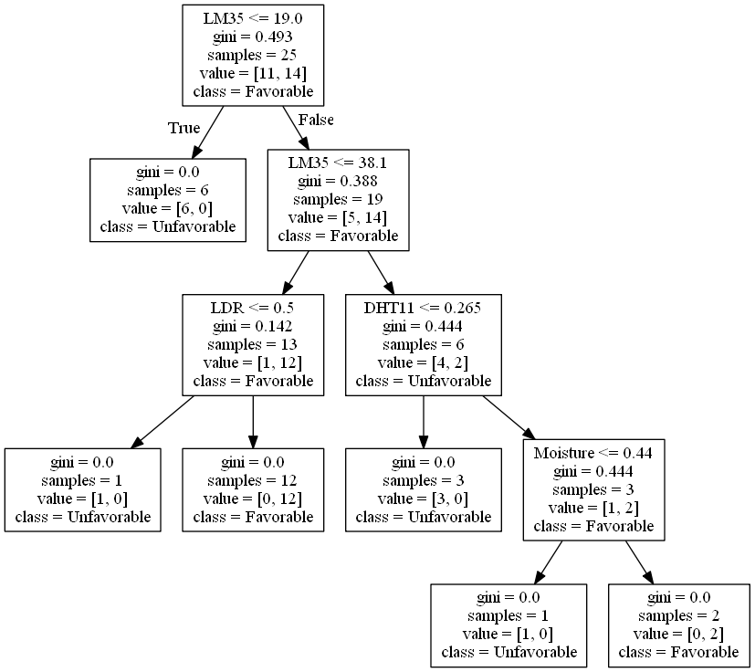
Fig. 21 Graph generated for Tree Constructed by decision Tree
Results:
One of the main advantages of the decision tree is that it can be interpreted as a set of rules. These rules are generated by traversing the tree starting from the root node until we reach some decision at a leaf. These rules also give a clear analytical view of the system under investigation as Fig 21. In our case, they will help understand the Environmental factors required for optimal ragi seed germination. The induced set of rules is stated in the below table.

TABLE 2
DECISION TREE RULES SET
RuleSet | Condition/Question
1. | IF LM35 < = 19.0 THEN “Unfavourable”
2. | IF LM35 > 19.0 AND LM35< =38.1 AND LDR < = 0.5 (Indirect low light) THEN “Unfavourable”
3. | IF LM35 > 19.0 AND LM35< =38.1 AND LDR > 0.5 (Direct bright light) THEN “Favourable”
4. | IF LM35 > 38.1 AND DHT11< = 0.265 THEN “Unfavourable”
5. | IF LM35 > 38.1 AND DHT11 > 0.265 AND Moisture < = 0.44 THEN “Unfavourable”
6. | IF LM35 > 38.1 AND DHT11 > 0.265 AND Moisture > 0.44 THEN “Favourable”

From the Induced Rule Set these are the Insights that can be made for Optimal Environmental Factors for Finger Millets Seeds germination:
1. Finger Millet's seeds germination requires a fairly high temperature above 19 degrees Celsius temperature.
2. Finger Millets Seeds would germinate well under bright Direct sunlight
3. High RH value favors easy germination of Finger Millets Seeds
4. Need to have high soil moisture content, Field capacity being around 0.44 value especially when temperature and humidity are high, which is intuitive as soil moisture would balance water loss by transpiration.

Therefore Finger Millets Seeds (ragi) is suitable to be germinated in a subtropical climate with drier conditions with long exposure to direct sunlight, in hot temperature as summers season with moderate levels of humidity and soil moisture requirements.
- applications OF methodology
The proposed system is capable of generating important insights about the suitable condition required by specific plant seed germination based on the data collected from sites having desired results and weak outputs, thereby given capacity to make educated judgments of Environmental conditions to be maintained for Optimized crop germination. These insights can be documented and spread across farmers to reap higher levels of profit and harvest. This Paper can also assist Agricultural engineers to do Hypothesis testing to plant seed subjects.

References
[1] R.Sindhuja and B.Krithiga, “Soil Nutrient Identification Using Arduino” Asian Journal of Applied Science and Technology (AJAST) Volume 1, Issue 4, Pages 40-42, May 2017

